Name _______________________________________________
Score ________
Phases of the Moon WebQuest Worksheet
As you observe the Moon over a month, you notice it changes. Sometimes the right side is in sunlight; other times it’s the left. Sometimes you see it at night; sometimes you see it during daytime.
This WebQuest will help you understand why the Moon changes shape throughout the month.
You will need to read the information available on the webpages you visit. All answers can be found one or more of the websites. Your task is to read and find the information.
Task One
There are eight major phases of the Moon. In the top of each square, write the phase of the Moon. In the circle, draw a picture of what it looks like.
Task Two
You have three terms that are used to describe the Moon. Define the following terms:  Gibbous - _____________________________________________________  Waxing - _____________________________________________________  Waning - _____________________________________________________
Complete the table identifying which phases are waxing and which are waning.
Phases of the Moon – Waxing | Phases of the Moon - Waning
Task Three
Draw a picture of the Moon phase on the day you were born.
My birthdate - ______________________________________________________
Draw a picture of the Moon phase on your birthday in 2013.
My birthdate - _________________________________________________, 20___

Task Four
Complete the table below showing the phase of the Moon each day during September 2013.
Moon Phases for September 2013 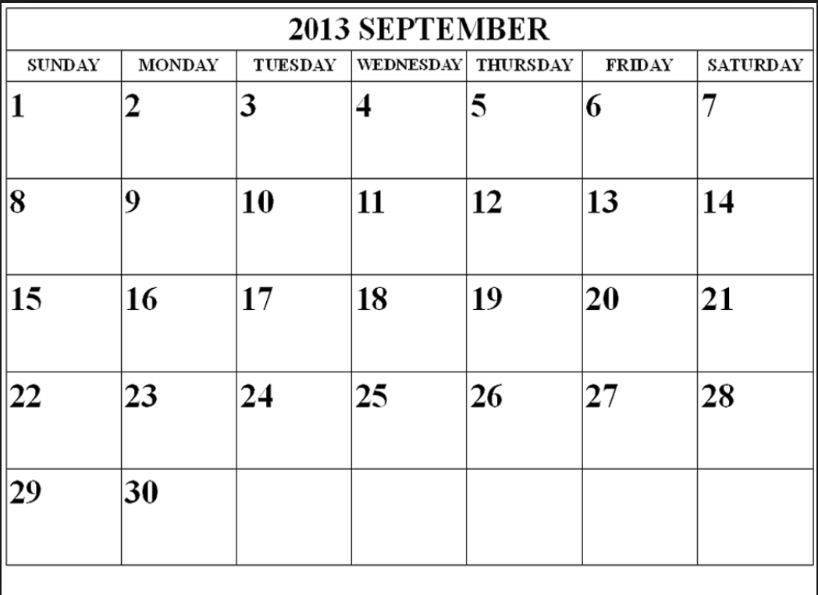Questions
1. Identify the days where the Moon’s phase is waxing crescent. ____________________________________________________2. Identify the days where the Moon’s phase is gibbous. ____________________________________________________3. Which day is the Moon full? ____________________________________________________4. Which day is the New Moon? ____________________________________________________5. Identify the days where the Moon’s phase is a waning crescent.
Task Five
Explain why the Moon, stars, and Sun appear to change positions in the sky. ___________________________________________________________________________________________________________________________________________________________________________ _________________________________________________________
Task Six
The Moon changes appearance throughout the month because of the position of the Earth, Moon, and Sun. Complete the table below, identifying the phase and drawing a picture of the correct Moon phase.
Task Seven
I have completed the "Phaser Quiz" with a score of six or higher.
_____ Teacher's Initials

